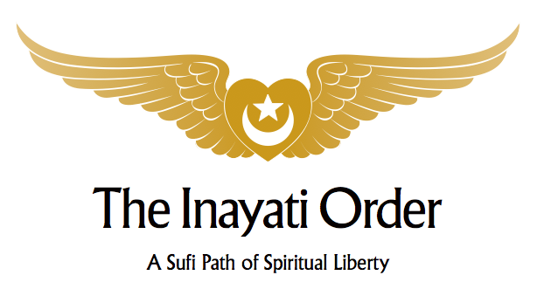

Wisdom of the Prophets – Part IV
Sufism & Judaism
Rabbi Tirzah Firestone, Netanel Miles-Yépez & Pir Zia Inayat-Khan
April 27-30, 2017, New Lebanon, New York

Schedule

Thursday, April 27th

2:00 – 6:00 pm Registration
6:00 – 6:45 pm Dinner
6:45 – 8:30 pm Welcome (Pir Zia, Reb Tizah & Reb Netanel)
Friday, April 28th

8:00 – 9:00 am Breakfast
9:00 – 10:30 am Exodus (Pir Zia)
10:30 – 11:00 am Tea Break
11:00 – 12:30 pm The Path of the Tzaddik: The All and the Nothing (Reb Tirzah)
12:30 – 1:30 pm Lunch
1:30 – 2:30 pm Free Time
2:30 – 3:45 pm The Merging of Two Oceans: Sufism and Hasidism I (Reb Netanel)
3:45 – 4:15 pm Tea Break
4:15 – 5:30 pm Ascent in Song (Pir Zia)
7:00 pm – 9 pm Shabbat Ritual, Stories, and Dinner (Reb Tirzah, Reb Netanel, Sunset 7:50 pm)

Saturday, April 29th (Shabbat)

8:00 – 9:00 am Breakfast
9:00 – 10:30 am A David Psalm (Pir Zia)
10:30 – 11:00 am Tea Break
11:00 – 12:30 pm Embodying Divine Love: The Precious Power of Incarnation (Rabbi Tirzah)
12:30 – 1:30 pm Lunch
1:30 – 3:00 pm Shabbat Nap
3:00 – 4:15 pm The Merging of Two Oceans: Sufism and Hasidism II (Reb Netanel)
4:15 – 5:30 pm Job (Pir Zia)
5:30 – 6:00 pm Tea Break
6:00 – 7:45 pm Sufi–Jewish Zikr
8:00 – 9:30 pm Havdalah Ceremony, Stories, and Dinner (Reb Tirzah, Sunset 7:51 pm)

Sunday, April 30th

8:00 – 9:00 am Breakfast
9:00 – 10:30 am Sohbet (Pir Zia, Reb Tirzah & Reb Netanel)
10:30 – 11:00 am Tea Break
11:00 – 12:30 pm Universal Worship (Pir Zia, Reb Tirzah & Reb Netanel)
12:30 – 1:30 pm Brunch

